Windows lomoagent install in detail:

1. Download the lomoagent.msi from lomorage.com
2. Double click lomoagent.msi, if you meet below picture:

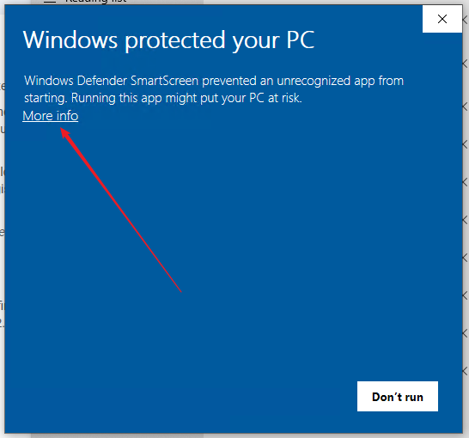

Click More info then you can see below:

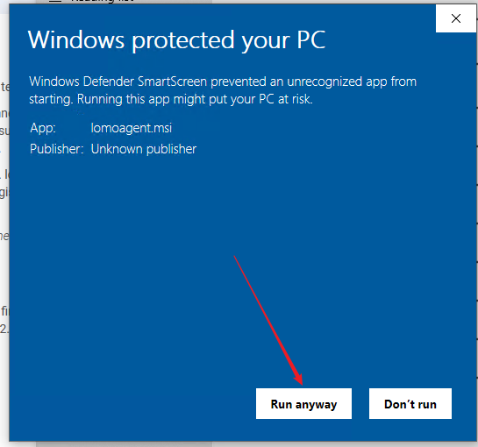

Then click **Run anyway** button.

And after a while, it will show below installation guide, and click next button:

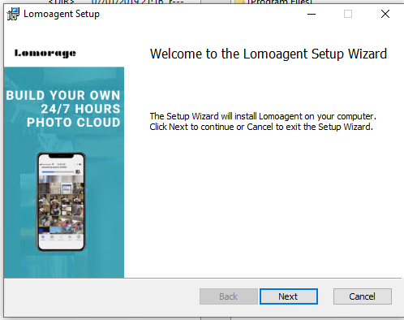

In the next page, check the checkbox as below picture:

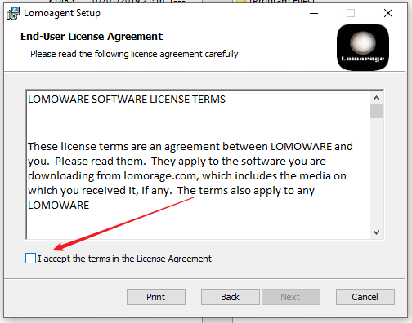

And click **next** button in next page.

Later lomoagent will installed into your windows machine like below picture.

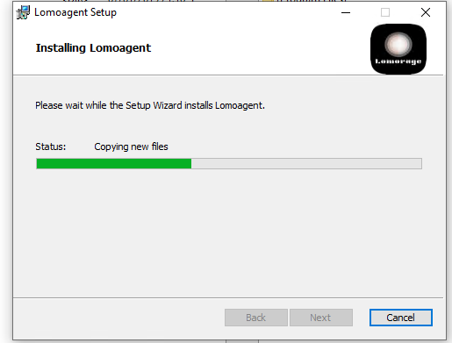

Last page should be like below:

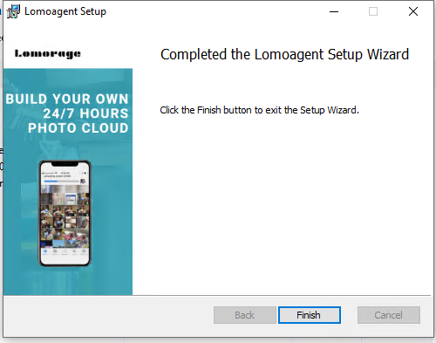

Now you should see the lomoagent icon on your desktop, you can double click the start the lomoagent.

If you meet below dialog popuped up by the Windows os, please click the Allow access.

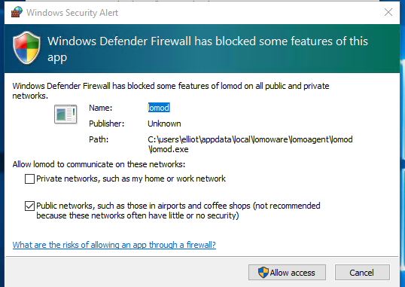

Now you got the lomoagent running on your windows.

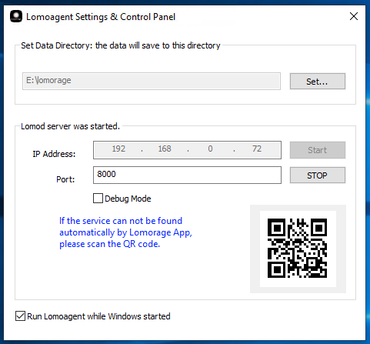

**Config the Data directory:**

This directory is to save the photos and videos uploading from your phone.

You can use the Lomorage APP on phone to scan the QR code or manually input this lomoagent IP.